TABLE OF CONTENTS:

1. DATASET used:

3D Velodyne sensor point cloud Kitti Dataset

1. Point cloud alignment with PCD files

Code :

Results:

1. Concatenation of point cloud:

Code:

Results:

1. Point cloud stitching with CARLA

CODE:

RESULTS:

## **DATASET used:**

### 3D Velodyne sensor point cloud Kitti Dataset

<http://www.cvlibs.net/datasets/kitti/raw_data.php>

1. From Carla

## **Point cloud alignment with PCD files**

#### **Code :**

<https://drive.google.com/file/d/12fh1qO_8GZ93um-VFTmtJHGmb7V60Igy/view?usp=sharing>

#### **Results:**

(<https://docs.google.com/presentation/d/1AGMPRlKVpc21TOEaxjnvC33yvsjWISSisEjFvc6jF4c/edit?usp=sharing> )

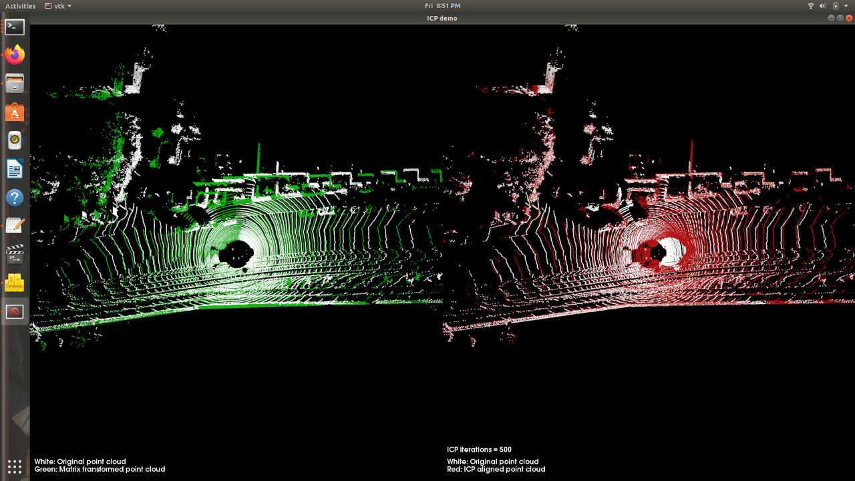

## **Concatenation of point cloud:**

#### **Code:**

<https://drive.google.com/file/d/1c4wTV9WO5t1b4rJAYZYkHZMO5jquzWDh/view?usp=sharing>

#### **Results:**

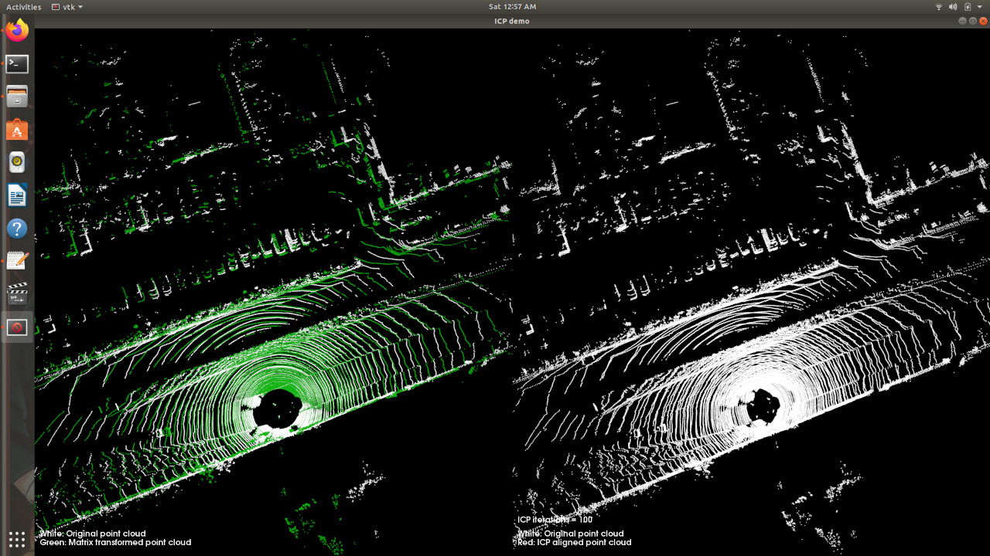

## **Point cloud stitching with CARLA**

#### **CODE:**

<https://drive.google.com/file/d/1eWE9f4GFv3bN1VMexKv9BdEdwZ5NzNfK/view?usp=sharing>

#### **RESULTS:**

1. <https://drive.google.com/file/d/1NsBMRydB47acckV8cl4dwwZ2TGGc0vNc/view?usp=sharing> (PCD file)

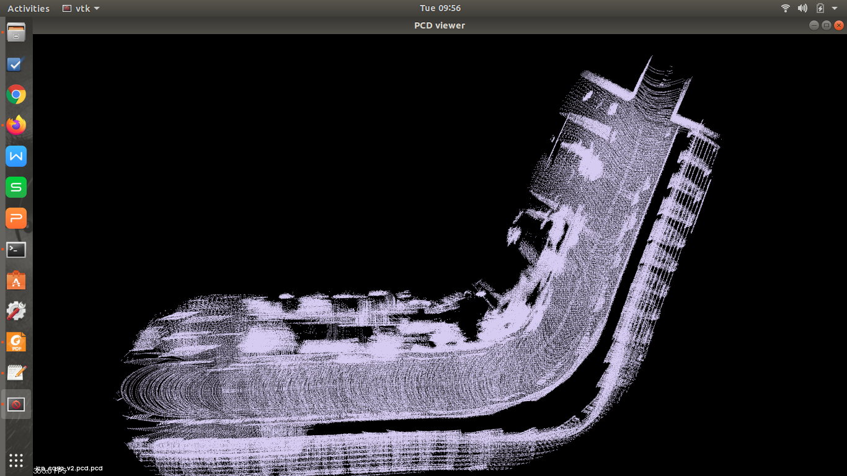

1. <https://drive.google.com/file/d/1fRDJea9RnAF8etGQK4jaPGYsudtjJnL8/view?usp=sharing> (PCD file)

